|  |  |
| --- | --- |
| Ex. No:10 | **Design of PID Controllers and Evaluation of Closed Loop Performance** |
| Date: |

**Aim**

To design PID controllers and evaluate the closed loop performance.

**Introduction**

**PID Controller**

A PID controller (Proportional, Integral, Derivative) is a feedback control system used in engineering. It has three components:

1. Proportional (P): Responds to the current error, reducing steady-state error and providing a quick response.

2. Integral (I): Considers accumulated past errors to eliminate steady-state error over time.

3. Derivative (D): Anticipates future errors by analyzing the rate of change of the error, contributing to stability.

**PID Controller Design**

The design of a PID controller involves tuning the three components (P, I, and D) to achieve the desired system performance. The tuning process is often an iterative one and involves adjusting the parameters to balance the trade-offs between responsiveness, stability, and minimizing overshoot.

1. Proportional Gain (Kp):

- Adjusting the proportional gain determines how much the controller responds to the current error.

- Increasing Kp makes the system more responsive but may lead to overshooting and oscillations.

- Decreasing Kp may result in sluggish response and increased steady-state error.

2. Integral Gain (Ki):

- The integral gain determines the impact of accumulated past errors on the control action.

- Increasing Ki helps eliminate steady-state error but may introduce overshoot and oscillations.

- Decreasing Ki can lead to a faster response but may result in a larger steady-state error.

3. Derivative Gain (Kd):

- The derivative gain influences the controller's response to the rate of change of the error.

- Increasing Kd improves stability and reduces overshoot but may slow down the system's response.

- Decreasing Kd can lead to increased overshoot and oscillations.

Tuning:

- PID controller tuning is often done experimentally, adjusting the gains until the desired system behavior is achieved.

- Various methods, such as trial-and-error, Ziegler-Nichols, or optimization algorithms, can be used for tuning.

**Procedure**

Step 1. Obtain an open-loop response and determine what needs to be improved

Step 2. Add a proportional control to increase the rise time.

Step 3. Add a derivative control to reduce the overshoot.

Step 4. Add an integral control to reduce the steady-state error

Step 5. Adjust each of the gains Kp, Ki, and Kd until you obtain a desired overall response. You can always refer to the table shown in this "PID Tutorial" page to find out which controller controls which characteristics.

**Matlab Circuit**

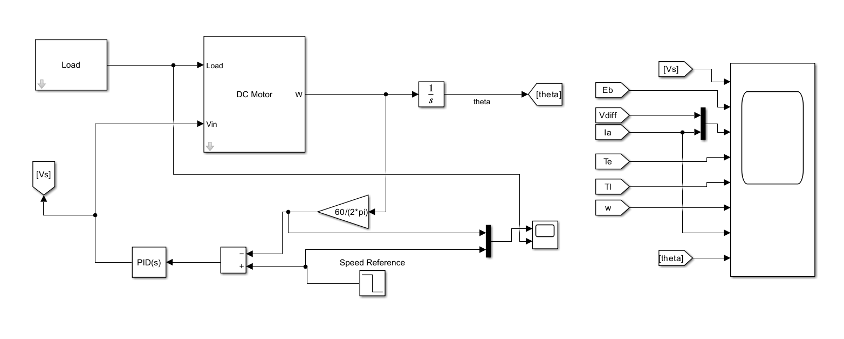

**DC Motor Subsystem**

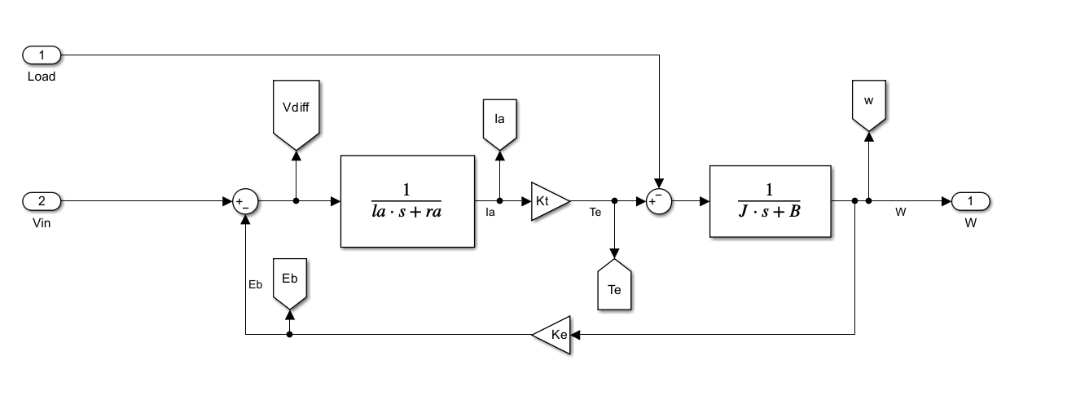

**Trail and Error Method**

Kp=1;

Ki=1;

Kd=0;

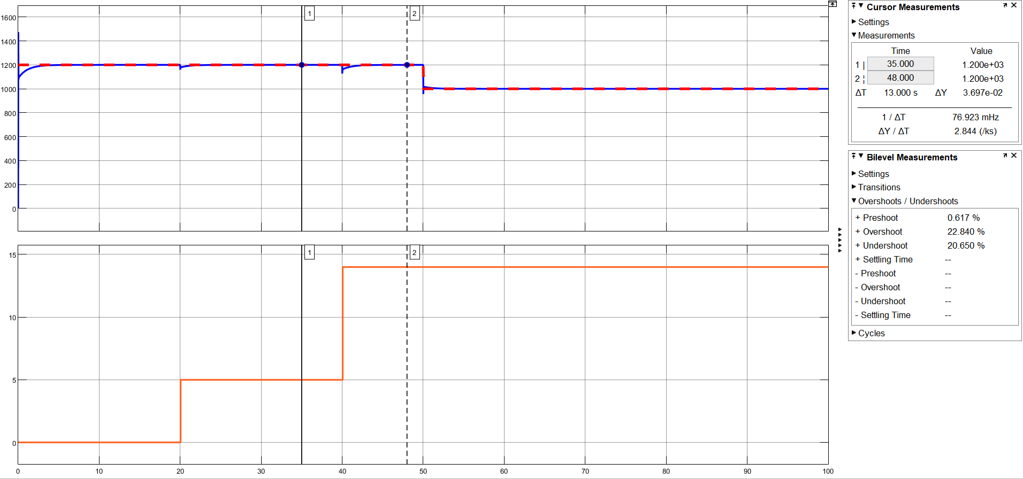

Kp = 10

Ki = 50

Kd = 0

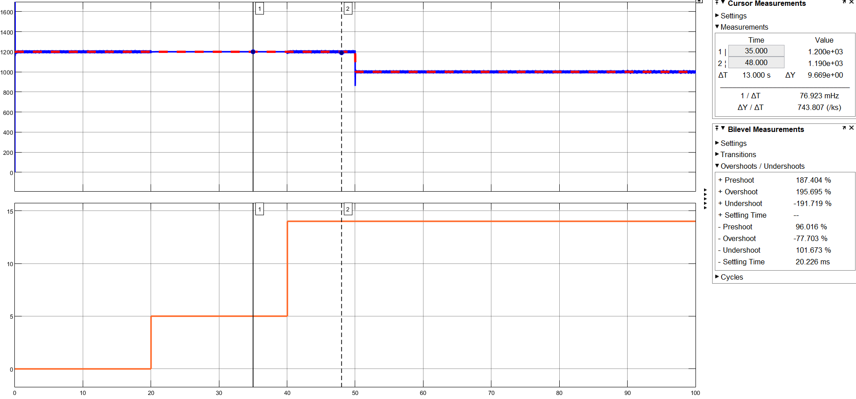

**After Tuning**

Kp = 0.68

Ki = 31.87

Kd = 0.0036

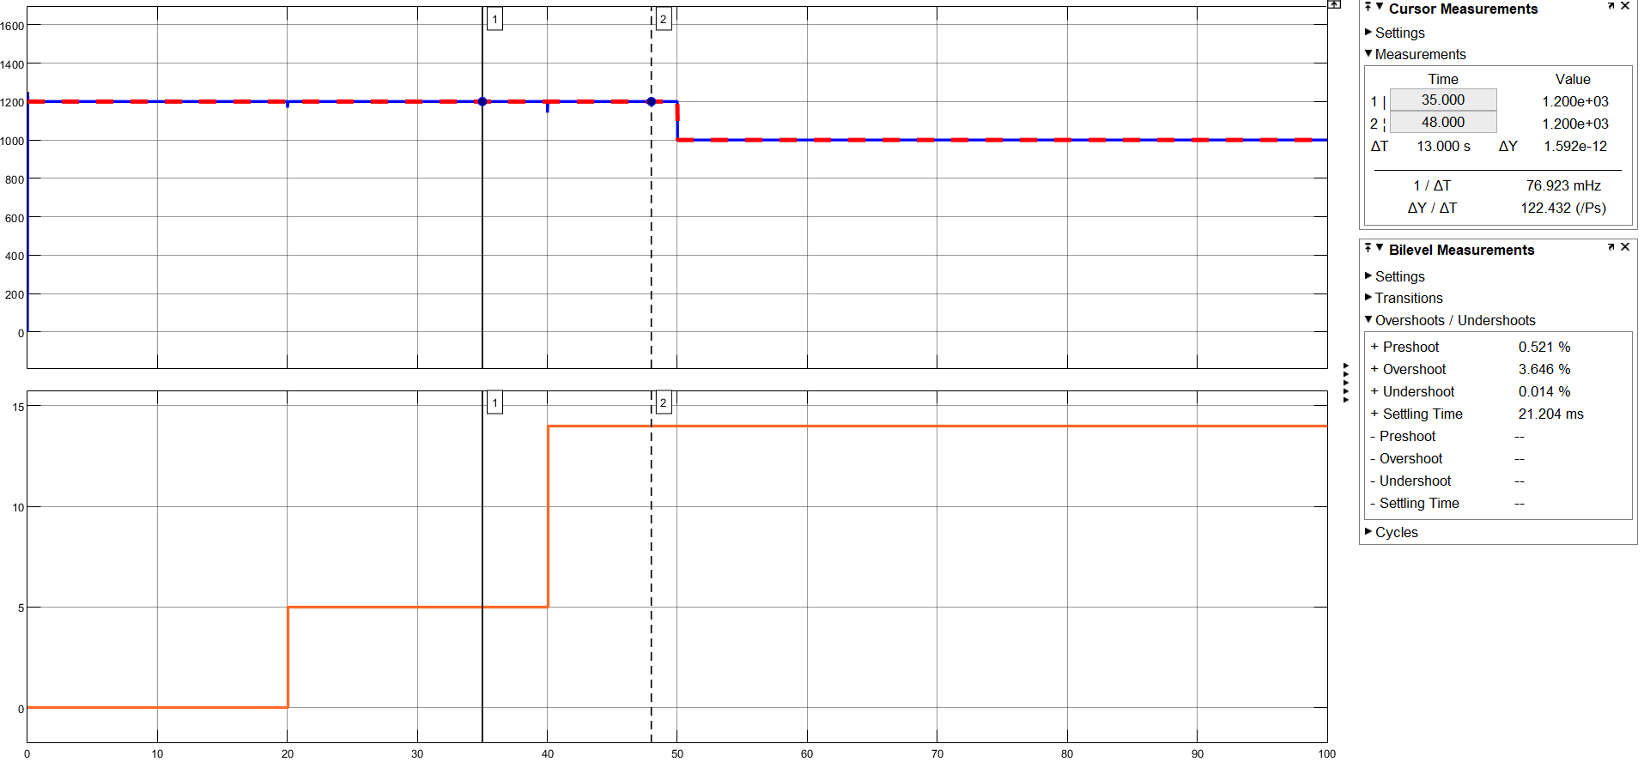

**Inference**

**Result**

Thus, design of PID controllers and evaluation of closed loop assessment performed using Matlab Simulink.